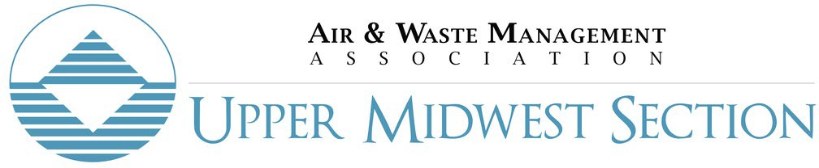

Board Meeting
March 12, 2024 11:00 AM
Microsoft Teams

Attendance
Name | Position | Present | Absent
Kathryn Anderson | Chair | X
Kelsey Suddard | Vice Chair, Program Planning Committee Chair | X
Hannah Mathers | Treasurer |  | X
Liam Brady | Secretary | X
Bill Norge | 2023-2025 Director | X
Jess Keller | 2024-2026 Director | X
Hassan Bouchareb | 2022-2024 Director | X
Shelley Koehn | Membership Committee Chair | X
Sam Helal | Young Professionals Committee Chair |  | X
John Ke | Communications Chair | X
Aisha Balogh | Education Committee Chair |  | X
(open) | COE Committee Chair
Roger Clarke | Arrowhead Conference Lead | X
Amanda Gravseth | North Dakota Conference Lead |  | X
Mike Hult | International A&WMA Liaison | X
Agenda
- Call to order
- Agenda review, additions & modifications
- Adoption of minutes from February board meeting Motion approved.
- Chair report & goal updates (Kathryn) No new updates.
- Vice Chair report & goal updates (Kelsey) PM2.5 webinar is scheduled for March 27th at 12 – 2:30 pm at the Barr Minneapolis office (4300 MartekPointe Drive Suite 200, Minneapolis, MN 55435). 7 people registered so far. Free to A&WMA members.
  - Program planning update (All) No new updates.
- Secretary report & goal updates (Liam) Annual report to be handed in on time this month.
- Treasurer report & goal updates (Hannah) No new updates.
Director/Nominating Committee updates (Bill, Hassan, Jess) Proposed changing the by-laws to allow terms for board to be two years long. The idea is to have Secretary and treasurer elections one year, chair and chair elect the next year. That way, board members aren’t all replaced every year. The section organization members must vote to approve by-laws updates to make this happen.
Discussion on how to implement two-year positions.
In past, vice chair, chair, past chair rotation. Was written out of by-laws pre-pandemic. Board member positions need to be elected positions per the by-laws.
Final plan: This year, everyone is elected with treasurer and secretary as two-year positions, chair and vice chair as one-year positions. Following year’s election is chair and vice chair only election with a two-year term.
Motion to change by laws to two-year positions for secretary, treasurer, char, vice chair. On alternating years for elections starting with secretary/treasurer and then chair/vice chair. 2024 elections will be held for all positions with two-year secretary/treasurer and one-year chair/vice chair, 2025 elections will be chair/vice chair only at two years.
Bill to update bylaws for the board to approve of these changes at the next meeting.
- Standing Committee reports & goal updates
  - Membership committee (Shelley) Steady at 138 members – gained 12 and lost 12 members. New folks include COE students. 39 people on lapsed list. Shelley to reach out to lapsed folks.
  - Education committee (Aisha) No new updates.
  - Communications Committee (John) Getting out emails for PM2.5 webinar. Website updates- please add a short bio of yourself for the website, see email from Kathryn. Sending out a save the date for COE soon.
- Ad Hoc Committee reports & goal updates
  - YP committee (Sam) Looking for a YP committee chair. Let Kathryn know if you have any people in mind.
  - Waste/Regional Conferences (Roger) Had solid waste operator conference on 2/21/24 with 81 attendees. There was 5 sponsors. The conference qualified for 6 CEUs for operator license. Currently wrapping up sending out checks- a total of $1,000 profit for AWMA. Shelley to do outreach survey to attendees to take advantage of AWMA membership.
According to Roger, the new website worked well for the conference.
Arrowhead Conference (Roger) Asking for $500 from our board to hire help for administration for the Arrowhead conference.In addition, asking for financial commitment of $750 to book room for conference.
Next Arrowhead conference will be hosted likely in October.
Motion to approve $500 for administrative help, $750 to book event. $1,250 total.
Motion is approved.
Discussion on soliciting support for conference to get people to learn how to run conference. Kathryn to reach out to people.
  - COE Committee (Kathryn – stand in) Still looking for someone to fill the COE position. Next conference is on November 7th, 2024. Kathryn met with CSWEA to discuss COE. Kathryn to send email to past committee members to see who is interested in helping plan COE for this year. Let Kathryn know if anyone is interested in helping.
  - North Dakota Conference (Amanda) North Dakota conference planning will start in next month.
  - International Update (Mike)
Sponsorship of ACE in Calgary, Canada request, think about it and vote at next meeting. $500 is a common reasonable sponsorship amount.
Kathryn to ask Hannah what we’ve done in past for sponsorship. Sponsorship by May is preferable. Vote on it next meeting.
Leadership Training Academy (LTA)- should vote on it today to allocate funds. No voting for LTA occurred today.
- Old business

- New business
  - YP to ACE Sponsorship This was not discussed in our meeting today. Tabled for next month.
    - Determine maximum amount to allocate
    - Last year’s deadlines – April 15 for application and awarded by May 2
  - Sponsorship of annual conference See notes above on the sponsorship.
  - April Leadership Training – April 19, 2024 See notes above on LTA.
  - Open position discussion – COE This was discussed earlier this meeting.
  - Website updates This was not discussed in our meeting today. Tabled for next month.
  - File Sharing location This was not discussed in our meeting today. Tabled for next month.
  - Seminar – planning update No new updates.

- Review action items, reminder for future meetings, and wrap-up.
- Adjourn Motion to end meeting was approved.

Month | Week of (Mondays) | Planned Activities (should be posted to Website Calendar) | Specific Event Date | Ideas
3 3/4/2024
3 3/11/2024 |  | Board Meeting | 3/12/2024
3 3/18/2024
3 3/25/2024 |  | 3-27-2024 - PM2.5 NAAQS Seminar | 3/27/2024
4 | 4/1/2024
4 | 4/8/2024 | Board Meeting | 4/9/2024
4 | 4/15/2024
4 | 4/22/2024
4 | 4/29/2024
5 5/6/2024
5 5/13/2024 |  | Board Meeting
5 5/20/2024
5 5/27/2024
6 | 6/3/2024
6 | 6/10/2024 | Board Meeting
6 | 6/17/2024
6 | 6/24/2024 |  |  | A&WMA's 115th Annual Conference and Exhibition

